Technologies for Literacy: Using Technologies in a Problem Solving Environment

Chwee Beng Lee
University of Western Sydney, Australia

As technologies have become an integral part of our lives, the way we read and understand text has changed drastically. In this paper, we discuss how various technologies support learners’ reading and writing skills within the context of meaningful learning. Next, using elaborated cases, we argue that situating learners in problem solving environments and engaging them in authentic tasks has far-reaching benefits for learning as technologies play the role of cognitive tools in such environments.

Key words: Technologies; problem solving; meaningful learning

Introduction

The rapid development of powerful new technologies and the demand to drive a knowledge based economy has propelled research in the field of learning technologies to explore and study the use of emerging technologies for learning as they become popular as either social or educational tools.

Most of our daily activities, be they social, work or school-related, are mediated through screen-based literacy. It has become common practice for teachers to teach with an interactive whiteboard, for students to readily snap a picture using their smart phones for their projects, to surf the Internet for related information for their classroom tasks, or to seek external help from peers through social network applications. The challenge for teachers is how to make their students’ learning meaningful with these new literacy practices. Some researchers have urged schools to explore ways of acknowledging new literacies or risk perpetuating an outdated curriculum which is unable to connect with students’ lives (Gee, 2004; Goodwyn, 2000; Pahl & Rowsell, 2005).

As technologies have become an integral part of our lives, the way we read and understand text has changed drastically. With the emergence of Web 2.0, it has become necessary to understand how learners can interact with technologies to make sense of the world around them. Text includes various semiotic methods such as graphics, pictures, audio, video, and both electronic and paper-based text. Many researchers recognise that the nature of ‘literacy’ is changing (Bearne, 2003; Kress, 1997) and that reading and writing in digital environments are very different from reading and writing in paper-based texts (Turbill & Murray, 2006). Therefore, it is imperative that school teachers are aware of the changes in literacy and that they help their students evaluate and learn from the new kinds of texts (Anstey & Bull, 2006). To be digitally literate, learners must develop strategies to access and read a variety of screen texts with fluency (Levy, 2009) and to write effectively with the appropriate technologies that are available to them. Given the complexity in learning, learners in the digital world are expected to develop appropriate skills to locate, organize, understand, analyse and even synthesize information from multiple digital sources. Digital texts characterized by its non-linearity and coupled with emerging technologies quickly transformed the way we write and how we write (Bronle, 2006). Armed with new technologies, learners enjoy the flexibility of choosing the type of technologies to aid in their learning and the platform to articulate their learning. As a result, the way we process our thoughts and articulating them require more effective and efficient strategies.

In this writing, we discuss how various technologies support learners’ reading and writing skills. Next, we argue that situating learners in problem solving environments and engaging them in authentic tasks has far-reaching benefits for learning as technologies play the role of cognitive tools in such environments.

Technologies for writing

Many studies have indicated the significant role of reflection in students’ writing process in order to improve their texts (Chen, Wei, Wu, & Uden, 2009; Vass, Littleton, Miell, & Jones, 2008; Xie, Ke, & Sharma, 2008).

Writing is one of the most important skills that students must acquire. It is a complex activity which requires the acquisition of several skills in order to perfect it. According to Flower, Schriver, Carey, Haas and Hayes (1989), students need to accomplish tasks such as setting goals, planning, idea organization, composition of text and editing. Such skills may be supported with technologies. Planning and idea organization are important processes in the realm of writing. Some researchers have found that learners do not know how to initiate and organize their thoughts and ideas (Author, 2006). Concept mapping is one of the most common activities in schools and it can be used across various disciplines. Concept maps are composed of nodes which are usually concepts or ideas, and links which are statements of relationships that connect the ideas. Concept maps help learners to build structural knowledge (see Jonassen, Bessimer, & Yassi, 1996) which is also referred to as cognitive structures. With concept maps, learners identify the important and related concepts and make meaningful relationships to connect them. Such a process helps learners to represent and understand the underlying structures of the concepts that they are trying to learn. Without knowing how concepts are interrelated, it is probably impossible to form a meaningful structure that explains their interconnectedness. Although concept maps can be drawn using paper and pencil, computer-based concept mapping tools allow easier production. Moreover, they have affordances which paper-based concept maps do not possess. Computer-based concept mapping tools allow users to easily edit their maps, and most of them are easily learned. However, teachers who plan to use concept mapping tools in their classroom must be aware that different tools have different affordances, and so evaluation must be carried out before the proper integration of such tools into their teaching. For instance, some concept mapping tools such as Cmap (http://cmap.ihmc.us) (see Fig 1) support collaboration, as users can retrieve their own or someone else’s map anytime, anywhere. A similar tool, Webspiration Classroom (http://www.inspiration.com/webspirationclassroom), also allows for online collaboration. In addition, it provides a variety of resources to aid students’ writing, and a chat feature for synchronous discussion. The other tool which supports online collaboration is Mindmeister (www.mindmeister.com) (see Fig 2). Although, strictly speaking, it is more of a mind mapping tool, it can be used to help learners organize and plan their ideas. The power of this tool is that it supports synchronous collaboration, which means that a group of students could actually work on the same map at the same time regardless of their locality. It also provides users with the flexibility to work on their maps using iPhone or iPad applications. Other concept mapping tools such as Inspiration (www.inspiration.com) (see Fig 3) cater more for elementary school students as it has a library of visual tools and graphics for students to work with when building their concept maps. It is user friendly and it scaffolds young learners in creating their initial maps. One of the most powerful semantic networking tools is Semantica Education as it offers students the opportunity to create dynamic rather than static maps. To build an elaborated map, users need to define the symmetric as well as asymmetric links between concepts. A list of possible relationships can be found with the application of scaffolding students’ thinking.
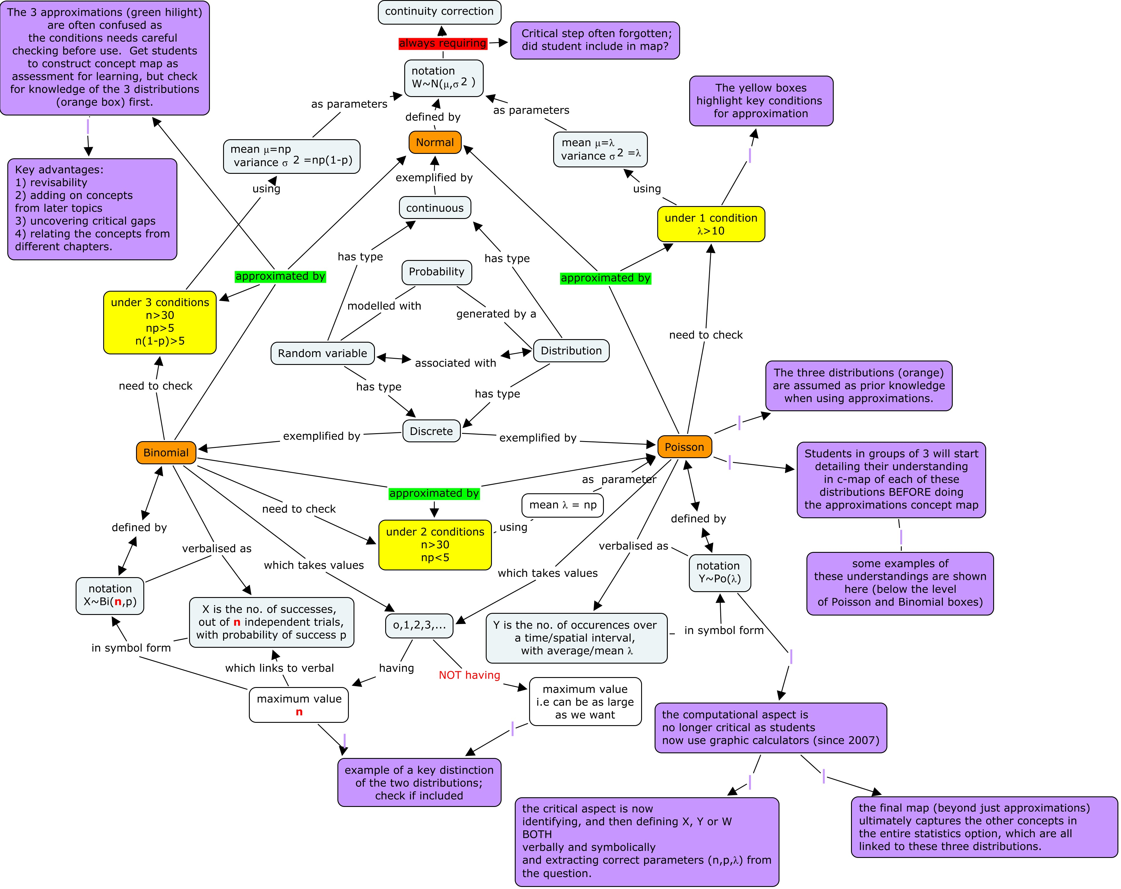

Figure 1: A concept map created using Cmap (courtesy of Wah Liang Teo)

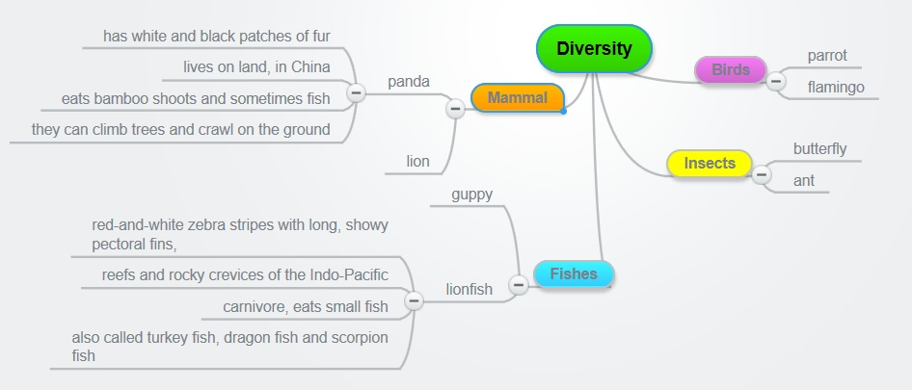
Figure 2: A mindmap created using Mindmeister (courtesy of Ya Li Goh, Kuan Wei Fong, Xueyi Huang and Jeslyn Ho)
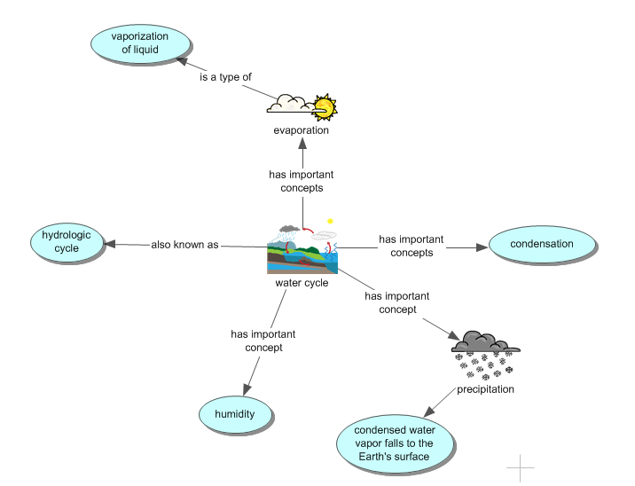
Figure 3: A concept map created using Inspiration

There are many uses of concept maps such as identifying students’ misconceptions (Kinchin, 2000; 2002), lesson planning (Kinchin & Alias, 2005), assessment (Edmondson, 2000), and cognitive typology (Kinchin, Hay, & Adams, 2000; Hay & Kinchin, 2006). In terms of writing, concept maps can be used as a planning or brainstorming tool. When students prepare to write an essay, they can create a concept map to help them gather and organize their ideas before the actual writing begins. It is quite common practice for students to conduct Internet searches for ideas relevant to the essay that they are writing. Hence, creating concept maps as they do their searching helps them to gather and organize their ideas. Such a process enables them to perform some levels of analysis as well. As they search for information and create the maps, they would have to analyse and evaluate their conceptions and determine the appropriate relationships describing the connections among these ideas. For instance, when preparing to write on Whirlpool, a student may search for related information through the readings from the Internet and create a concept map using Semantic Education (See Fig 4).

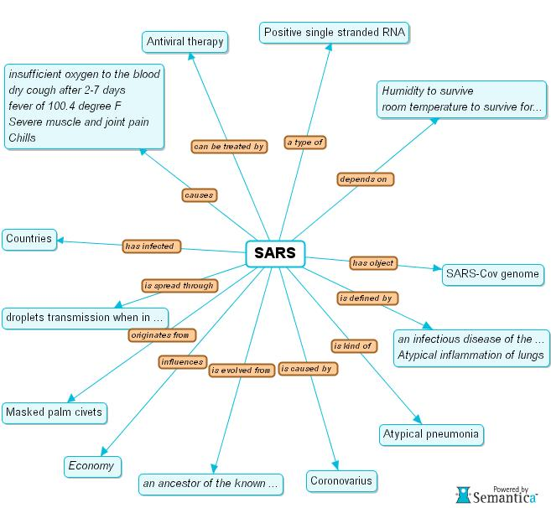
Figure 4: A concept map created using Semantica Education (courtesy of Meng Hoe Koh)

Besides using concept mapping tools to organize ideas for writing, argumentation tools may be used to help students rationalize their ideas. When students learn to argue, they are engaged in deeper and more mature epistemological levels of learning (Jonassen & Kim, 2010). This cognitive process is critical in writing, especially when students are preparing to write persuasive and argumentative essays. There are various argument types (Jonassen & Kim, 2010) and most computer-based argumentation tools are built based on Toulmin’s (1958) rhetorical argumentation model. Rhetorical arguments are the most common form of argumentation, and the aim of such arguments is to persuade or convince others of a claim or proposition. Tools such as Compendium (http://compendium.open.ac.uk ) allow students to visually map out and manage their arguments (see Fig 5). By constructing their argument maps, they analyse and construct their arguments logically. Another tool which helps students in building their reasoning skills and structuring their arguments is Rationale (http://austhink.com/ ) (see Fig 6). By using a set of organizing, questioning and reasoning tools provided by the software, users embark on a guided thinking process.
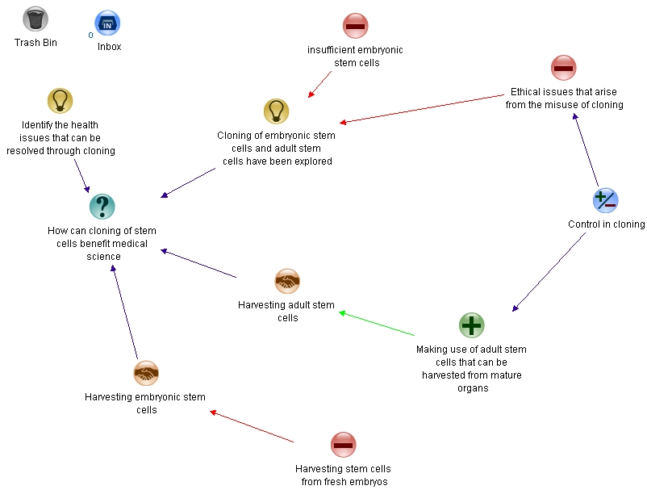
Figure 5: A visual argument map created using Compendium (courtesy of Nicholas Ng)

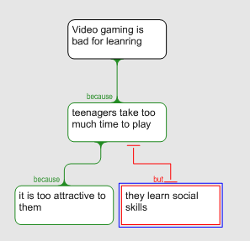
Figure 6: An argument map drawn using Rationale

In recent years, technologies have played a significant role in helping learners to build learning communities and schools to introduce various online platforms to their students in the hope of getting them to learn from each other through online interactions. Scardamalia and Beriter (2006) and Beriter and Scadamalia (1996), who have discussed at great length and conducted much research in the area of knowledge building, argue that knowledge building communities should support students in actively pursuing learning as a goal, which is considered as intentional learning. In knowledge building, students learn to treat ideas as improvable and learn to respect and value ideas according to their contributions to the group’s knowledge base. The ideas proposed by students, regardless of how naïve they are, are considered as valuable and meaningful contributions, and initial ideas which may lack scientific explanations are regarded as a crucial starting point in the process of constructive idea improvement. To engage in idea improvement, students use the online discussion platforms Knowledge Forum (see Figure 7) for their knowledge building activity. In Knowledge Forum, teachers provide scaffolding phrases such as “My theory is,” “I need to understand,” “My theory cannot explain” or “A better theory is.” Students are supported in advancing their metacognitive and epistemic capacity by constantly examining their understanding (Author, 2010). In a knowledge building community, students own the learning and the knowledge as they explore and build on their understanding. As students scrutinize their own messages as well as their peers’ messages, they consciously pay more attention to the way they articulate their thoughts and make efforts to refine and improve their writings. Knowledge forums are designed and developed to support knowledge building communities. However, teachers must note that cultivating a knowledge building culture is far more important than simply situating students in the online platform. Students must learn that it is a community effort to improve ideas and that all members must work towards this common goal.

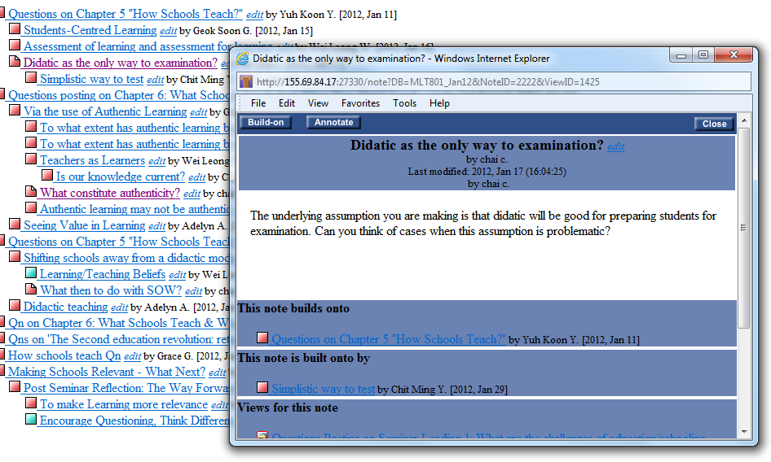
Figure 7: Knowledge forum discussion (courtesy of Ching Sing Chai)

Technologies for reading

Reading is one of the most critical components of learning. Almost everything that we encounter on a daily basis requires some level of comprehension. Every subject and content that we learn in school depends on our ability to read effectively and digest the information for meaningful learning. Hasselbring and Goin (2004) found that the variables that correlated most strongly with reading comprehension ability were the number of books read and the amount of time spent reading. Based on this finding, it seems imperative to have students read more to improve their literacy. However, the challenges for educators are how best they can motivate their students to want to read more and how to ensure that students are reading efficiently for sense making. The above questions are even more acute when students are exposed to the multi-modalities of literacy. As such, the way we encourage students to want to read must change as they may need more dynamic and differentiated avenues for reading in order to stay engaged (Prensky, 2005).

Accessing the Internet for relevant information has become common practice in teaching and learning. Using online text has the affordance of non-linearity and it creates flexibility in terms of reading (Kommers et al., 1996; McKnight et al., 1996; Park & Helsel, 2008). Interestingly, some researchers (Sakar & Ercetin, 2005) have found that videos and pictures are learners’ favourite and most helpful online resources and that learners use online videos and pictures to support their reading activities (Mayer, 1997; Park & Kim, 2011). Students accessing Internet resources are not passive learners; they will actively and creatively use the various types of resources for their meaning making process. To enhance students’ reading, the use of Internet information may help to create some levels of motivation as they are empowered with the flexibility to read and comprehend information through various avenues. However, one of the most important steps for students to be able to use appropriate Internet information is to develop the ability to evaluate the sources (Colaric & Jonassen, 2001) which is a critical skill for effective reading. When students locate prospective websites, they must consider the relevancy and credibility of the information. A series of questions such as whether the website’s aims are aligned with the students’ intentions, whether it offers sufficient information for the student to make sense out of it, whether it comes from reliable institutions/organizations, and whether the information is accurate and logical are to be answered when the student is trying to decipher whether the information is relevant and credible. When students evaluate the reliability and credibility of the information, they are necessarily engaged in reflective thinking. Reflective thinking enables students to process their thinking critically for better comprehension.

In recent years wikis have fast become an integral part of teaching and learning as educators and teachers start to acknowledge its affordances. As open source server software, they provide users with the flexibility to easily add, remove, or edit the available content. Wikis offer an online environment for students to engage in collaborative tasks. One of the most important affordances of wikis is that they allow co-authorship of content which promotes the ownership of learning. As students constantly improve their co-authored work, they undergo processes of analysing and evaluating the appropriateness of their shared work. This process requires a high level of concentration on reading and understanding the available content. Although wikis are mostly used as a collaborative writing tool, they can facilitate reading and comprehension as well. Because of their collaborative nature, students can provide peer feedback on each other’s work and assist in proofreading. In addition, wikis have the feature of allowing users to monitor the progress of the content development as they can track the history of changes which helps them to compare differences between multiple versions of the document that they are co-preparing (Huang & Nakazawa, 2010). One of the most popular wikis, PBworks (http://www.pbworks.com) (see Fig 8) offers users a user-friendly collaborative environment. It is widely used in educational settings as it has both the affordances of an educational platform and it can offer a safe online environment for users. Users may choose any template to guide them in their initial set-up of their wiki site, and the site owner can provide various administrative roles to the group members to monitor the levels of activity. Once group members access the site, they can start building the content collaboratively. PBworks also allows users to flexibly embed videos, audio files and picture files to enhance the content of their work. With the high sharing responsibility, roles are distributed and students usually assume the ownership of making sure that the content is appropriate and relevant.

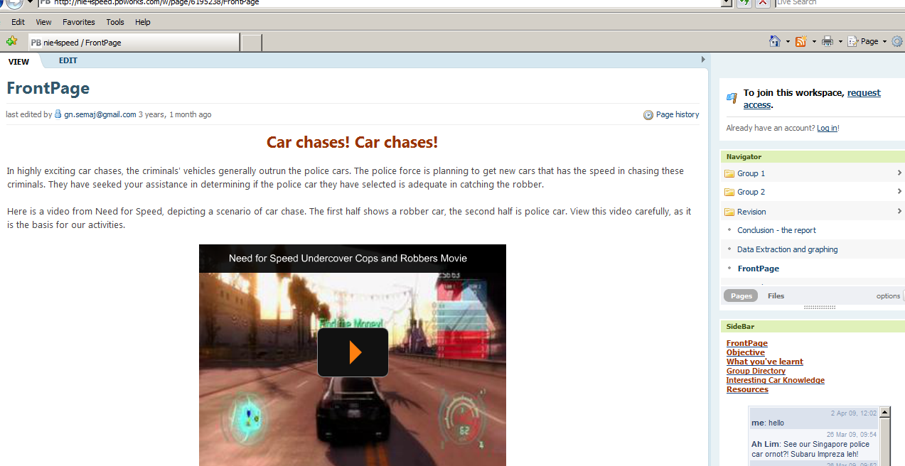
Figure 8: An online unit created using PBworks

Technologies for meaningful learning

With the proliferation of emerging technologies, educators and teachers must bear in mind that what is important is not which tool to use but rather selecting the appropriate technologies that can support the specific tasks for the fulfilment of particular learning outcomes. When technologies are used to foster learning, they are not used as an information delivery vehicle, but rather they engage learners in thinking. Jonassen, Howland, Marra and Crismond (2008) describe the characteristics of meaningful learning. These researchers argue that in order for students to learn meaningfully, they must be willing to engage in meaningful tasks and these tasks should be active, intentional, constructive, authentic and cooperative. To elaborate, learners should engage in active manipulation of the objects and tools around them to learn about the environment. However, being active is not sufficient; they have to articulate what they have learned and reflect upon their learning in order to construct meanings. Next, learning has to be intentional because all the activities that we do have intended outcomes. Berieter and Scadamalia (1989) suggest that learners are not only active in their construction of meaning, but can also be intentional, which means that they are cognitively engaged in the learning process, monitoring and regulating their learning (Sinatra & Pintrich, 2003). Authentic tasks can help students to appreciate their learning much better as they are situated in real-world contexts. Finally, students must learn to cooperate with each other in the meaning making process as all human beings naturally work together.

Designing for meaningful learning: Problem solving framework

Technologies can play various roles in helping learners to achieve meaningful learning. According to Jonassen, Howland, Marra and Crismond (2008), technologies can help learners to represent their ideas and understanding; they can be used to form intellectual partnerships with learners or to create an authentic context to support learning, or as a social medium to support learning. Among all tasks, problem solving tasks are the most meaningful. After all, everything that we do or encounter daily is about problem solving. For instance, we have to decide on which alternative route to take when there is a road closure, how to better manage a student with behavioural problems or which superannuation package to sign up for. In this writing, we argue that having students solve ill-structured problems with technologies enables them to understand and learn better. Ill-structured problems which we usually encounter in everyday life and work often possess conflicting goals, incomplete information, multiple solution methods, and multiple criteria for evaluating solutions. There is also a high level of uncertainty about the application of rules and principles necessary for the solution (Author et al., 2009). In a recent study, Author (2010) argues that problem solving intervention can help students to become aware of the inconsistencies between their naive theories and the scientific ones and create and deep learning intentional learning.When solving ill-structured problems, students experience perturbations as they question their own hypotheses and inquiries. This creates the ownership of learning and the retention of knowledge.

In recent years, there have been calls for teachers to teach in intelligent and flexible manner (Zohar, 2006; Bransford, Derry, Berliner, Hammerness & Beckett, 2005). This is so as the work of teachers is most of the time unpredictable (Spillane, Resier & Reimer, 2002) and the kinds of problems teachers solve can be highly ill-structured and dynamic. In respond to such calls, various constructivist approaches such as problem-based learning which aim to develop effective problem solvers and the transfer of skills and knowledge is included in teacher preparation programs (Savin-Baden, 2000; Tan et al., 2000). One assumption we made in this paper is that having pre-service teachers engaged in design problems will foster their ability in dealing with ill-structured problems because of its cyclical nature of learning, design thinking benefits from reflection in action (Cheng, 2000; Webster, 2001).

In the two cases that follow, we discuss how technologies can foster thinking in a problem solving environment.

Case 1: Who Killed Maloney?

This is a problem solving task created by a group of pre-service teachers specializing in the teaching of English and Literature in high schools. In this case, high school students are tasked to solve a murder case. Through solving the case, they learn specific skills such as listening, analysing, and speaking skills. When students access this website which is created with PBworks (www.pbworks.com) they immediately access the Newsflash which gives an account of the recent murder case of Detective Maloney and what they need to do as detectives. The students can either read the newsflash or click the short video clip (see Figure 10) created with xtranormal (www.xtranormal.com). Next, the students continue to play the role of detectives by listening to eyewitnesses, as this is what police detectives do most of the time. They could click any of the links to the key eyewitnesses to listen to their accounts and, at any time, students could re-play any of the audio files. A template is provided to guide them in drawing out critical information from the accounts. To investigate the case further, the students then embark on task 2 which requires them to view case files such as crime scene photos, transcripts of eyewitnesses’ accounts, suspect profiles and the coroner’s report. The third task (see Figure 11) requires students to collaboratively build a mind map using Mindmeister (www.mindmeister.com) to explain the possible causes of Detective Maloney’s death and determine who the possible culprit is. The final task requires students to formulate a report individually and this is done through using Voxopop (www.voxopop.com) to record an oral report.

The roles of technologies in this problem solving environment are diverse yet important. First of all, PBworks provides a flexible environment for students to engage in collaborative work. Students can freely access any of the resources and video/audio files to examine and investigate the case. The use of the short video files created by the teachers themselves captures the attention of learners. Moreover, it represents the problem for the learners to solve. The use of online mind maps helps students to collaboratively organize their thoughts and ideas and scaffolds them for the final task which is their oral report. Technologies in this environment support thinking and engage students in a variety of authentic tasks rather than simply providing information. Through solving the given problem, students actively manipulate the information provided and decipher which is most appropriate for their meaning making process. Students are expected to examine and evaluate the various forms of information provided and analyse the situation based on multiple perspectives. As the problem presented to the students is authentic and engaging, they construct their own mental models and explain their thoughts through the collaborative building of a mind map.

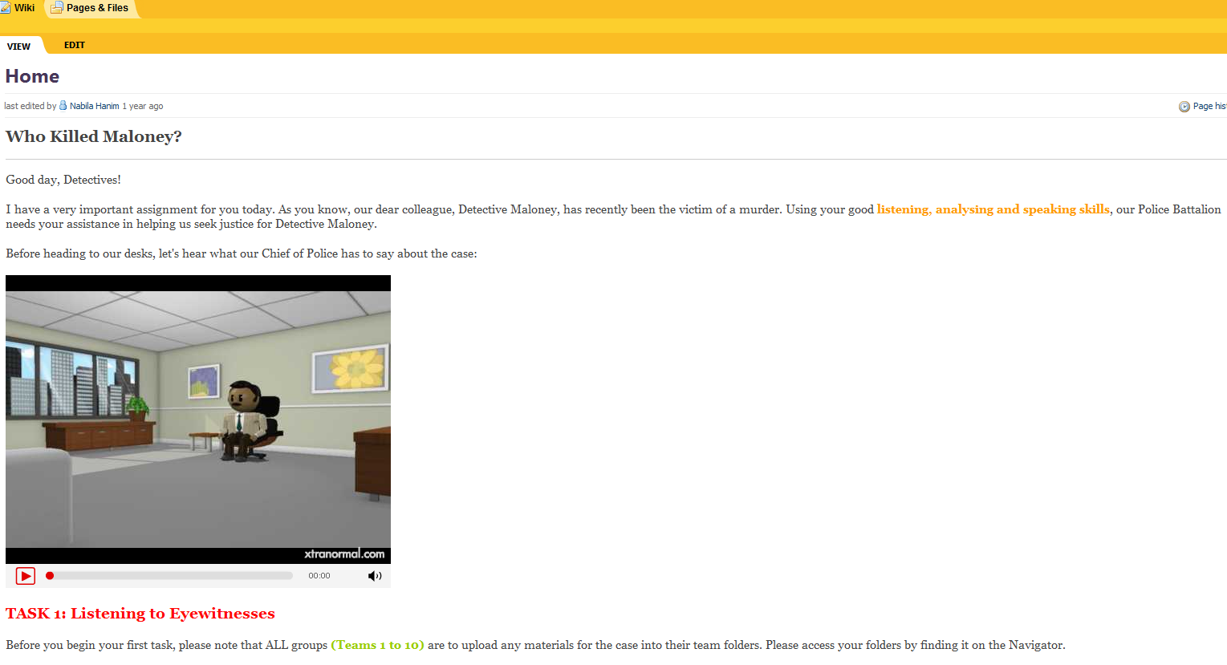
Figure 10: “Who killed Maloney” created using PBworks (courtesy of Nabila, Maimunah, Irnish, and Idriaty)

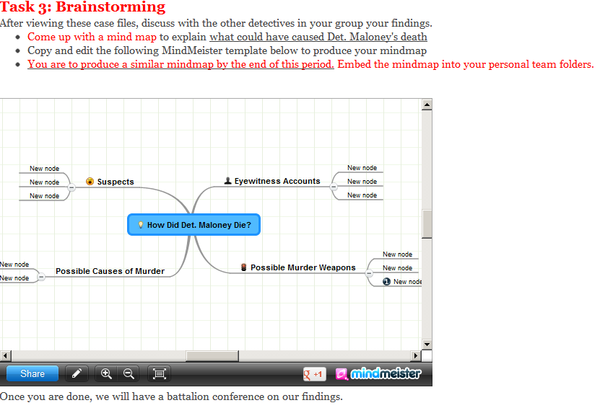
Figure 11: A mindmap created using PBworks (courtesy of Nabila, Maimunah, Irnish, and Idriaty)

Case 2: “Welcome to Dr. Tay’s THE FAMILY CLINIC”

This is an online learning environment designed and created by a group of pre-service teachers specializing in teaching high school science. Using PBworks as a platform, the teachers designed a series of activities for high school students learning the concepts of the human digestive system. Students play the role of a first year medical student during a two month internship programme, and are given a chance to learn in Dr Tay’s clinic. They are to learn from Dr. Tay about diagnosing patients’ health problems, and at the end of the internship they are required to give a short reflection to the medical school and do some assessments to test their proficiency. The medical students start off by watching video clips (see Figure 12) (produced by the pre-service teachers who designed this online unit) and then analyse the condition of the patient, identify factors that cause the condition and suggest possible preventive measures. The last activity requires these medical students to embark on a series of proficiency tests (see Figure 13). To complete the tasks given in this online unit, students have to exercise their reading and listening skills.

In this case, the problems are represented through the use of video clips which are produced by the designers of the lesson unit. As the videos represent real life scenarios, they may be more efficient in capturing the attention of students and engaging them in solving the problems. The high school students who play the role of an intern medical doctor have to listen and watch the video clips carefully to be able to pick up the information for their analysis. They then take the proficiency tests which are produced using hotpotatoes (http://hotpot.uvic.ca/) embedded in this learning unit. These tests are not mainly for drill and practice purposes but rather to aid in students’ thinking. To be specific, constructive feedbacks which encourage students to engage in deeper thinking is embedded (see Figure 14) with the test items. Such mechanism helps students to exercise various cognitive processes such as analysis and reflection. This provides students with an opportunity to monitor their progress and the achievement of their learning goals.

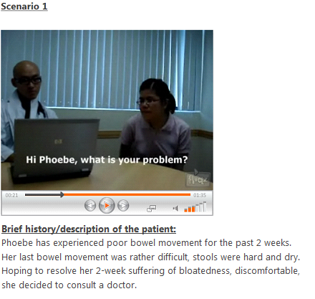
Figure 12: Video clips to represent problems for students to solve (courtesy of Rui Yin See, Poh Boon The, Jia Ling Tha and Wei Leen Wong)

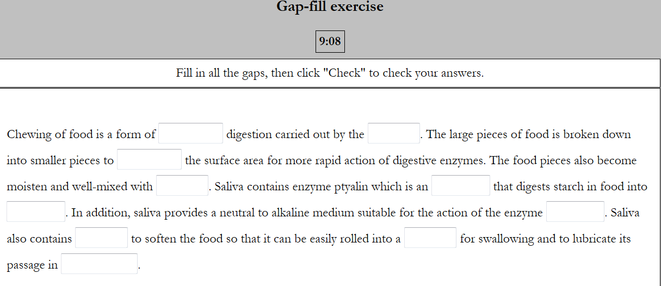
Figure 13: Formative test items created using Hotpotatoes (courtesy of Rui Yin See, Poh Boon The, Jia Ling Tha and Wei Leen Wong)

Figure 14: Formative test item showing constructive feedback (courtesy of Rui Yin See, Poh Boon The, Jia Ling Tha and Wei Leen Wong)

Instructional and research implications

The two cases given above illustrate the possibility of using problem solving as a framework for the design of meaningful learning with technologies. Technologies in these cases are used to represent problems for students to solve, present an authentic learning environment, encourage multiple perspectives, support brainstorming and thinking, foster collaborative work and help students to monitor their learning progress and goals

One of the reasons that students are unable to transfer their classroom knowledge to their everyday and professional contexts is that most of the time they are only exposed to well-structured problems, usually story problems which are highly predictable and requires a finite set of rules and applications to solve (Jonassen, 2003). Hence, when designing problem solving tasks which are meaningful, teachers should consider:

- Create or use problems that resonate with the students’ everyday experiences (e.g., asking Australian students to solve the water problem in Africa has little meaning to them).
- Design tasks that are authentic and aligned with the given problem (e.g., it won’t make sense if you ask students to solve a medical problem and yet at the end of the day, they have to do a class presentation. Doctors don’t present in class).
- Embedded or activities that will help students to monitor their learning (this can be done through the use of online assessment tools with constructive feedback) must be embedded
- Incorporate activities that require cooperative or collaborative work (in the real world, no one works in isolation).

In addition to the above instructional considerations, there must be opportunities for students to represent their understanding in multiple ways so as to build sophisticated mental models for the transfer of knowledge and skills (Singly & Anderson, 1989). When students are able to represent their understanding in numerous ways, they necessarily build stronger connections between the various types of knowledge, such as procedural knowledge, declarative knowledge and structural knowledge. Assessing the effectiveness of problem solving requires the consideration of a systemic approach. Given that problem solving is a highly complex cognitive process and consists of complex tasks (van Merrienboer, 2012), using a single method of assessment is simply not sufficient as it flattens the multidimensional nature of problem solving (Jonassen, 2011). In order to provide a systemic assessment on problem solving, Jonassen (2011) suggested different aspects of assessment: 1. the knowledge about problem schemas, 2. problem solving performance, and 3, cognitive skills (e.g. causal reasoning and argumentative skills). Apart from the above recommendations, we suggest adopting a design-based research methodology when conducting research in the field of problem solving with technologies. The methodology of design-based research has developed over the past several years with the intention of developing a deep understanding of what makes for successful educational practices (Barab & Kirshner, 2001). Design-based research emphasizes deepening theoretical understanding and contributing to practical dissemination (Brown, 1992) and one of the characteristics of design-based research is that it is process-oriented and iterative in nature (Barab & Squire, 2004). Thus, an interactive research design allows for constant evaluation and optimal improvement of our learning environment design and, ultimately, of preservice teachers’ ability to problem solve.

Conclusion

In this writing, we have discussed various technologies for fostering students’ literacy skills. We have also argued the need for meaningful learning with technologies. Technologies must support and foster thinking rather than simply play a passive role as an information delivery vehicle. Most importantly, technologies should be integrated into a larger constructivist learning environment to foster meaningful learning. In this paper, we have discussed how technologies can play critical roles in problem solving environments for meaningful learning through two cases. Problem solving as the most authentic human cognitive activity should be integrated into school curricula (Author et al., 2009) as it may provide students with opportunities to explore and discover the limits of their understanding and engage them in deep learning. Hopefully, this writing is able to provide some guidance to educators and teachers who are considering integrating technologies into their teaching.

References

Beng Lee, C. et al. (2009). The Role of Model Building in Problem Solving and Conceptual Change. Journal of Interactive Learning Environments, 19(3), 247-265
Beng Lee, C. (2010). Generating synergy between knowledge building and conceptual change, Human Development, 53(3), 134-152.
Anstey, M., & Bull, G. (2006). Teaching and learning multiliteracies: Changing times, changing literacies. Newark, DE: International Reading Association.Barab, S., & Kirshner, D. (2001). Methodologies for capturing learner practices occurring as part of dynamic learning environments. The Journal of the Learning Sciences, 10(1), 5-15.
Barab, S, & Squire, K. (2004). Design-based research: Putting a stake in the ground. The Journal of the Learning Sciences, 13(1), 1-14.
Bransford, J., Derry, S., Berliner, D., Hammerness, K., & Beckett, K. L. (2005). Theories of learning and their roles in teaching. In L. Darling-Hammond & J. Bransford (Eds.), Preparing teachers for a changing world: What teachers should learn and be able to do (pp.40-87). San Francisco, CA: Jossey-Bass.
Brown, A. L. (1992). Design experiments: Theoretical and methodological challenges in creating complex interventions in classroom settings. Journal of the Learning Sciences, 2(2), 141–178.
Bromley, K. (2006). Technology and writing. In M.C., Mckenna, L.D., Labbo., R. D., Kieffer., & D. Reinking (Eds.). International Handbook of Literacy and Technology (pp. 349-354). Mahwah, NJ: Lawrence and Erlbaum.
Chen, N. S.,Wei, C.W.,Wu, K. T., & Uden, L. (2009). Effects of high level prompts and peer assessment on online learners’ reflection levels. Computers & Education, 52, 283–291.
Bereiter, C., & Scardamalia, M. (1989). Intentional learning as a goal of instruction, In L. B. Resnick (Ed.), Knowing, learning and instruction: Essays in honor of Robert Glaser (pp.361-392). Hillsdale, NJ: Lawrence Erlbaum Associates.
Bereiter, C., & Sardamalia, M. (1996). Rethinking learning. In D. R., Olson & N. Torrance (Eds.), The handbook of education and human development: New models of learning, teaching and schooling. Cambridge, MA: Blackwell
Bearne, E. (2003). Rethinking literacy; communication, representation and text. Reading Literacy and Language, 37(3), 98–103.
Colaric, S., & Jonassen, D. (2001) Information equals knowledge, searching equals learning, and hyperlinking is good instruction: Myths about learning from the World Wide Web. Computers in Schools, 17, 159-169.
Edmondson, K.M. 2000. Assessing science understanding through concept maps. In Assessing science understanding: A human constructivist view, ed. J.J. Mintzes, J.H. Wandersee, and J.D. Novak, 15–40. San Diego, CA: Academic Press.
Flower, L., Schriver, K. A., Haas, C., & Hayes, J. R. (1989). Planning in writing. The cognition of a constructive process. Technical Report 34, Center for the study of Writing. Carnegie Mellon University.
Gee, J. (2004). Situated language and learning: A critique of traditional schooling. London: Routledge.
Goodwyn, A. (Ed.) (2000). English in the digital age: Information and Communications Technology and the teaching of English. London: Cassell.
Hasselbring, T. S., & Goin, L. I. (2004). Literacy instruction for older struggling readers: What is the role of technology? Reading and Writing Quarterly, 20(2), 123–144.
Hay, D.B., and I.M. Kinchin. 2006. Using concept maps to reveal conceptual typologies. Education and Training 48, 79–83.
Huang, Wen-Hao David Huang & Kazuaki Nakazawa (2010): An empirical analysis on how learners interact in wiki in a graduate level online course, Interactive Learning Environments, 18(3), 233-244
Kress, G. (1997). Before writing – rethinking the paths to literacy. London: Routledge.
Jonassen, D.H., Beissner, K., & Yacci, M. (1993). Structural Knowledge: Techniques for Assessing, Conveying, and Acquiring Structural Knowledge. Hillsdale, NJ: Lawrence Erlbaum.
Jonassen, D. H. (2011). Learning to solve problems: A handbook for designing problem solving learning environments. NY: Routledge.
Jonassen, D. H., & Kim, B. (2010). Arguing to learn and learning to argue: Design justifications and guidelines. Educational Technology: Research & Development, 58(4), 439-457.
Jonassen, D., Howland, J., Marra, R. & Crismond, D. (2008). Meaningful learning with technology, 3rd ed. Upper Saddle River, NJ: Pearson Education.
Kinchin, I.M. 2000. Using concept mapping to reveal understanding: A two tier analysis. School Science Review 296, 41–6.
Kinchin, I.M. 2002. Why professional development should challenge teachers’ core beliefs. School Science Review 306, 77–82.
Kinchin, I.M., D.B. Hay, and A. Adams. 2000. How a qualitative approach to concept map analysis can be used to aid learning by illustrating patterns of conceptual development. Educational Research 42(1), 43–57.
Lee, C. F. (2006). A study of teacher’s perceptions of writing instruction at junior high schools. Unpublished master’s thesis, Kaohsiung, Taiwan: National Sun Yat-Sen University.
Levy, R. (2009). ‘You have to understand words…but not read them’: Young Children becoming readers in digital age. Journal of Research in Reading, 32(1), 75-91.
Kommers, P. A. M., Grabinger, S., & Dunlap, J. C. (1996). Hypermedia learning environments: Instructional design and integration. Hillsdale, NJ: Lawrence Erlbaum Associates.
Mayer, R. E. (1997). Multimedia learning: are we asking the right questions? Educational Psychologist, 32(1), 1–19.
McKnight, C., Dillon, A., & Richardson, J. (1996). User-centered design of hypertext/hypermedia for education. In D. H. Jonassen (Ed.), Handbook of research for educational communications and technology (pp. 622–633). NY: Macmillan Library Reference.
Park, H. R., & Kim, D. (2011). Reading-strategy use by English as a second language learners in online reading tasks. Computers & Education, 57, 2156-2166.
Park, H., & Helsel, C. (2008). Differences between reading electronic and book-based text: suggestions and implications for literacy teachers and literacy teacher educators. Journal of Reading Education, 33(3), 28–31.
Pahl, K. & Rowsell, J. (2005). Literacy and education: Understanding the New Literacy Studies in the classroom. London: Paul Chapman Publishing.
Prensky, M. (2005). Engage me or enrage me: What today’s learners demand. Educause Review, 40(5), 61–64.
Sakar, A., & Ercetin, G. (2005). Effectiveness of hypermedia annotations for foreign language reading. Journal of Computer Assisted Learning, 21, 28–38.
Savin-Baden, M. (2000) Problem-based learning in higher education: untold stories. Philadelphia, PA; Society for Research into Higher Education: Open University Press.
Spillane, J.P., Reiser, B.J., & Reimar, T. (2002). Policy implementation and cognition: Reframing and refocusing implementation research. Review of Educational Research, 72, 387-431.
Scardamalia, M., & Bereiter, C. (2006). Knowledge building: Theory, pedagogy, and technology. In R. K. Sawyer (Ed.), The Cambridge handbook of the learning sciences (pp. 97-118). Cambridge, England: Cambridge University Press.
Sinatra, G. M., & Pintrich, P. R. (2003). The role of intentions in conceptual learning. In G. M. Sinatra & P. R. Pintrich (Eds.), Intentional conceptual change (pp. 1-18). Mahwah, NJ: Lawrence Erlbaum.
Tan, O. S., Little, P., Hee, S. Y. & Conway, J (Eds.) Problem-based learning: Educational innovation across discipline. Singapore: Temasek Centre for Problem-based Learning
Toulmin, S. (1959). The Uses of Argument. Cambridge: University Press.
Turbill, J., & Murray, J. (2006). Early literacy and new technologies in Australian schools: Policy, research and practice. In M.C., Mckenna, L.D. Labbo, R. D. Kieffer, & D. Reinking (Eds.), International Handbook of Literacy and Technology. (pp. 93-108). NJ: Mahwah, Lawrence Erlbaum Associates.
Vass, E., Littleton, K., Miell, D., & Jones, A. (2008). The discourse of collaborative creative writing: peer collaboration as a context for mutual inspiration. Thinking Skills and Creativity, 3(3), 192–202.
Xie, Y., Ke, F., & Sharma, P. (2008). The effect of peer feedback for blogging on college students’ reflective learning processes. Internet and Higher Education, 11, 18–25.
Zohar, A. (2006). The nature and development of teachers’ metastrategic knowledge in the context of teaching higher order thinking. Journal of the Learning Sciences, 15(3), 331-377.

